thesaker.is

A multi-level analysis of the US cruise missile attack on Syria and its consequences
The Saker
The latest US cruise missile attack on the Syrian airbase is an extremely important event in so many ways that it is important to examine it in some detail. I will try to do this today with the hope to be able to shed some light on a rather bizarre attack which will nevertheless have profound consequences. But first, let’s begin by looking at what actually happened.
The pretext:
I don’t think that anybody seriously believes that Assad or anybody else in the Syrian government really ordered a chemical weapons attack on anybody. To believe that it would require you to find the following sequence logical: first, Assad pretty much wins the war against Daesh which is in full retreat. Then, the US declares that overthrowing Assad is not a priority anymore (up to here this is all factual and true). Then, Assad decides to use weapons he does not have. He decides to bomb a location with no military value, but with lots of kids and cameras. Then, when the Russians demand a full investigation, the Americans strike as fast as they can before this idea gets any support. And now the Americans are probing a possible Russian role in this so-called attack. Frankly, if you believe any of that, you should immediately stop reading and go back to watching TV. For the rest of us, there are three options:
- a classical US-executed false flag
- a Syrian strike on a location which happened to be storing some kind of gas, possibly chlorine, but most definitely not sarin. This option requires you to believe in coincidences. I don’t. Unless,
- the US fed bad intelligence to the Syrians and got them to bomb a location where the US knew that toxic gas was stored.
What is evident is that the Syrians did not drop chemical weapons from their aircraft and that no chemical gas was ever stored at the al-Shayrat airbase. There is no footage showing any munitions or containers which would have delivered the toxic gas. As for US and other radar recordings, all they can show is that an aircraft was in the sky, its heading, altitude and speed. There is no way to distinguish a chemical munition or a chemical attack by means of radar.
Whatever option you chose, the Syrian government is obviously and self-evidently innocent of the accusation of having used chemical weapons. This is most likely a false flag attack.
Also, and just for the record, the US had been considering exactly such a false flag attack in the past. You can read everything about this plan here and here.
The attack:
American and Russian sources both agree on the following facts: 2 USN ships launched 59 Tomahawk cruise missiles at the Al Shayrat airfield in Syria. The US did not consult with the Russians on a political level, but through military channels the US gave Russia 2 hours advance warning. At this point the accounts begin to differ.
The Americans say that all missiles hit their targets. The Russians say that only 23 cruise missiles hit the airfield. The others are “unaccounted for”. Here I think that it is indisputable that the Americans are lying and the Russians are saying the truth: the main runway is intact (the Russian reporters provided footage proving this) and only one taxiway was hit. Furthermore, the Syrian Air Force resumed its operations within 24 hours. 36 cruise missiles have not reached their intended target. That is a fact.
It is also indisputable that there were no chemical munitions at this base as nobody, neither the Syrians nor the Russian reporters, had to wear any protective gear.
The missiles used in the attack, the Tomahawk, can use any combination of three guidance systems: GPS, inertial navigation and terrain mapping. There is no evidence and even no reports that the Russians shot even a single air-defense missile. In fact, the Russians had signed a memorandum with the USA which specifically comitting Russia NOT to interfere with any US overflights, manned or not, over Syria (and vice versa). While the Tomahawk cruise missile was developed in the 1980s, there is no reason to believe that the missiles used had exceeded their shelf live and there is even evidence that they were built in 2014. The Tomahawk is known to be accurate and reliable. There is absolutely no basis to suspect that over half of the missiles fired simply spontaneously malfunctioned. I therefore see only two possible explanations for what happened to the 36 missing cruise missiles:
Explanation A: Trump never intended to really hit the Syrians hard and this entire attack was just “for show” and the USN deliberately destroyed these missiles over the Mediterranean. That would make it possible for Trump to appear tough while not inflicting the kind of damage which would truly wreck his plans to collaborate with Russia. I do not believe in this explanation and I will explain why in the political analysis below.
Explanation B: The Russians could not legally shoot down the US missiles. Furthermore, it is incorrect to assume that these cruise missiles flew a direct course from the Mediterranean to their target (thereby almost overflying the Russian radar positions). Tomahawk were specifically built to be able to fly tangential courses around some radar types and they also have a very low RCS (radar visibility), especially in the frontal sector. Some of these missiles were probably flying low enough not to be seen by Russian radars, unless the Russians had an AWACS in the air (I don’t know if they did). However, since the Russians were warned about the attack they had plenty of time to prepare their electronic warfare stations to “fry” and otherwise disable at least part of the cruise missiles. I do believe that this is the correct explanation. I do not know whether the Russian were technically unable to destroy and confuse the 23 missiles which reached the base or whether a political decision was taken to let less than half of the cruise missiles through in order to disguise the Russian role in the destruction of 36 missiles. What I am sure of is that 36 advanced cruise missile do not “just disappear”. There are two reasons why the Russians would have decided to use their EW systems and not their missiles: first, it provides them “plausible deninability” (at least for the general public, there is no doubt that US signal intelligence units did detect the Russian electronic interference (unless it happened at very low power and very high frequency and far away inland), and because by using EW systems it allowed them to keep their air defense missiles for the protection of their own forces. Can the Russian really do this?
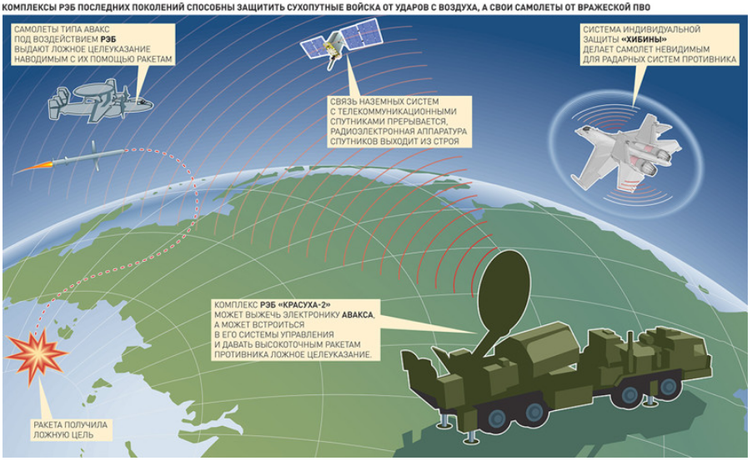
Take a look at this image, taken from a Russian website, which appears to have been made by the company Kret which produces some of the key Russian electronic warfare systems. Do you notice that on the left hand side, right under the AWACs aircraft you can clearly see a Tomahawk type missile turning around and eventually exploding at sea?
How this is done is open to conjecture. All that we are told is that the missile is given a “false target” but for our purposes this really does not matter. What matters is that the Russians have basically leaked the information that they are capable of turning cruise missiles around. There are other possibilities such as an directed energy beams which basically fries or, at least, confuses the terrain following and or inertial navigation systems. Some have suggested a “kill switch” which would shut down the entire missile. Maybe. Again, this really doesn’t matter for our purposes. What matters is that the Russian have the means to spoof, redirect or destroy US cruise missiles. It sure appears to be that for the first time these systems were used in anger.
[Sidebar: for those interested in seeing what such a system looks like here is a short video made by the Russians themselves showing how such a system is deployed and operated:
In terms of technical details, or we are told that this system can jam any airborne object at a distance of 200km]
I would note that those who say that the Russian air defense systems did not work don’t know what they are talking about. Not only did Russia sign an agreement with the US not to interfere with US flight operations, the Russian air defenses in Syria are NOT tasked with the protection of the Syrian Air Space. That is a task for the Syrian air defenses. The Russians air defenses in Syria are only here to protect Russian personnel and equipment. This is why the Russians never targeted Israeli warplanes. And this is hardly surprising as the Russian task force in Syria never had the mission to shut down the Syrian air space or, even less so, to start a war with the USA or Israel.
However, this might be changing. Now the Russians have withdrawn from their agreement with the USA and, even more importantly, have have declared that the Syrians urgently need more advanced air defense capabilities. Currently the Syrians operate very few advanced Russian air defense systems, most of their gear is old.
Legal aspects of the attack:
The US attack happened in direct violation of US law, of international law and of the UN charter. First, I would say that there is strong legal evidence that the US attack violated the US Constitution, Presidential War Powers Act and the 2001 Authorization of Military Force (AUMF) resolution. But since I don’t really care about this aspect of Trump’s criminal behavior, I will just refer you to two pretty good analyses of this issue (see here and here) and just simply summarize the argument of those who say that what Trump did was legal. It boils down to this: “yeah, it’s illegal, but all US Presidents have been doing it for so long that they have thereby created a legal precedent which, uh, makes it legal after all“. I don’t think this kind of “defense” is worthy of a reply or rebuttal. So now let’s turn to international law.
Most people think that crimes against humanity or genocide must be the ultimate crime under international law. They are wrong. The ultimate crime is aggression. This is the conclusion of the Nuremberg Trial on this topic:
To initiate a war of aggression, therefore, is not only an international crime; it is the supreme international crime differing only from other war crimes in that it contains within itself the accumulated evil of the whole.
So, following the long and prestigious list of other US Presidents before him, Donald Trump is now a war criminal. In fact, he is a “supreme war criminal”. It only took him 77 days to achieve this status, probably some kind of a record.
As for the UN Charter, at least for articles (1, 2, 33, 39) ban the kind of aggression the USA took against Syria.
I think that there is no need to dwell on the total illegality of this attack. I would just underscore the supreme irony of a country basically built by and run by lawyers (just see how many of them there are in Congress) whose general population seems to be totally indifferent to the fact that their elected representatives act in a completely illegal manner. All that most American people care about is whether the illegal action brings victory or not. But if it does, absolutely nobody cares. You disagree? Tell me, how many peace demonstrations were there in the USA about the totally illegal US aggression on Yugoslavia? Exactly. QED.
Political consequences (internal)
My son perfectly summed up what Trump’s actions have resulted in: “those who hated him still hate him while those who supported him now also hate him“. Wow! How did Trump and his advisors fail to predict that? Instead of fulfilling his numerous campaign promises (and his own Twitter statements) Trump decided to suddenly make a 180 and totally betray everything he stood for. I can’t think of a dumber action, I really can’t. I have to say that Trump now appears to make Dubya look smart. But there is much, much worse.
The worst aspect of this clusterf**k is how utterly immoral this makes Trump appear. Think of it – first Trump abjectly betrayed Flynn. Then he betrayed Bannon.
[Sidebar: I mostly liked Flynn. I had no use for Bannon at all. But the fact is that they were not my best friends, they were Trump’s best friends. And instead of standing up for them, he sacrificed them to the always bloodthirsty Neocons in the hope of appeasing them. This is what I wrote about this stupid and deeply immoral betrayal the day it happened:
Remember how Obama showed his true face when he hypocritically denounced his friend and pastor Rev. Jeremiah Wright Jr.? Today, Trump has shown us his true face. Instead of refusing Flynn’s resignation and instead of firing those who dared cook up these ridiculous accusations against Flynn, Trump accepted the resignation. This is not only an act of abject cowardice, it is also an amazingly stupid and self-defeating betrayal because now Trump will be alone, completely alone, facing the likes of Mattis and Pence – hard Cold Warrior types, ideological to the core, folks who want war and simply don’t care about reality.
The worst aspect of that is that by betraying people left and right Trump has now shown that you cannot trust him, that he will backstab you with no hesitation whatsoever. Would you ever take a risk for a guy like that? Contrast that with Putin who is “notorious” for standing by his friends and allies even when they do something really wrong! There is a reason why the AngloZionists could not break Putin and why it only took them one month to neuter Trump: Putin is made of titanium, Trump is just an overcooked noodle]
And now Trump has betrayed HIMSELF by turning against everything he, himself, stood for. This is almost Shakespearean in its pathetic and tragic aspects!
During his campaign Trump made a lot of excellent promises and he did inspire millions of Americans to support him. I personally believe that he was sincere in his intentions, and I don’t buy the “it was all an act” theory at all. Just look at the total panic of the Neocons at the prospects of a Trump victory and tell me this was all fake. No, I think that Trump was sincere. But when confronted with the ruthless opposition of the Neocons and the US deep state, Trump snapped and instantly broke because he is clearly completely spineless and has the ethics and morals of a trailer park prostitute.
So what we really have is a sad and pathetic version of Obama. A kind of Obama 2.0 if you want. The man inspired millions, he promised change you can believe in, and he delivered absolutely nothing except for an abject subservience to the real masters and owners of the United States: the Neocons and the deep state.
Trump did get what he apparently wanted, though: the very same corporate media which he claimed to despise is now praising him. And nobody is calling him a “Putin agent” any more. None of which will prevent the Neocons from impeaching him, by the way. He chose a quickfix solution which will stop acting in just days. How totally stupid of him. He apparently also chose the option of an “attack for show” to begin with, which turned into one of the most pathetic attacks in history, probably courtesy of Russian EW, and now that the USA has wasted something in the range of 100 million dollars, what does Trump have to show? A few flattering articles from the media which he has always hated and which will return to hate him as soon as ordered to do so by its Neocon masters. Pathetic if you ask me.
Ever since he got into the White House, Trump has been acting like your prototypical appeaser (it makes me wonder if his father was an alcoholic). How a guy like him ever made in business is a mystery to me, but what is now clear is that the Neocons totally submitted him and that they will now turn him into political roadkill.
I am afraid that the next four years (or less!) will turn into a neverending Purim celebration…
Political consequences (external)
Trump has single handedly destroyed any hopes of a US collaboration with Russia of any kind. Worse, he has also destroyed any hopes of being able to defeat Daesh. Why? Because if you really believe that Daesh can be defeated without Russian and Iranian support I want to sell you bridges all over the world. It ain’t happening. What is much, much worse is that now we are again on a pre-war situation, just as we were with Obama and would have been with Clinton. Let me explain.
The following are the measures with Russia has taken following the US attack on Syria:
- Denunciation at UN (to be expected, no big deal)
- Decision to strengthen the Syrian air defenses (big deal, that will give the Syrians the means to lock their airspace)
- Decision to cancel the Memorandum with the USA (now the Russians in Syria will have the right to decide whether to shoot or not)
- Decision to shut down the phone hot line with the US military (now the US won’t be able to call the Russians to ask them to do or not do something)
The combination of decisions 2, 3 and 4 does not mean that the Russians will shoot the next time, not by itself. The Russians will still be restricted by their own rules of engagement and by political decisions. But this will dramatically affect the US decision-making since from now on there will be no guarantee that the Russians will not shoot either. The Russians basically own the Syrian airspace already. What they want to do next is to give a similar capability to the Syrians. Not only will that allow the Syrians to defend themselves against any future US or Israeli attacks, it will provide the Russians plausible deniabilty the day they decide to shoot down a US aircraft or drone. Finally, the Russians are rushing back some of their most advanced ships towards the Syrian coast. So after giving Trump the benefit of the doubt, the Russians are now returning to a Obama-times like posture in Syria. Bravo Trump, well done!
Yes, I know, Tillerson is expected to meet Lavrov this week. This was discussed ad nauseam on Russian TV and the consensus is that the only reason why the Russians did not cancel this meeting is because they don’t want, on general principle, to be the ones to refuse to speak to the other side. Fine. Considering that we are talking about a potential international thermonuclear war, I can see the point. Still, I would have preferred to say Lavrov telling Tillerson to go and get lost. Why? Because I have come to the conclusion that any and all types of dialog with the United States are simply a meaningless and useless waste of time. For one thing, there is no US policy on anything. Over the past week or so we saw both Nikki Haley and Rex Tillerson completely contradict themselves over and over again: “no we don’t want to overthrow Assad. Yes we do want to overthrow Assad. Yes we do. No we don’t“. This is almost painful and embarrassing to watch. This just goes to show that just like the Obama Administration, the Trump people are “недоговороспособны” or “not agreement capable”. I explain this term in this analysis (written about Obama! Not Trump):
The Russians expressed their total disgust and outrage at this attack and openly began saying that the Americans were “недоговороспособны”. What that word means is literally “not-agreement-capable” or unable to make and then abide by an agreement. While polite, this expression is also extremely strong as it implies not so much a deliberate deception as the lack of the very ability to make a deal and abide by it. For example, the Russians have often said that the Kiev regime is “not-agreement-capable”, and that makes sense considering that the Nazi occupied Ukraine is essentially a failed state. But to say that a nuclear world superpower is “not-agreement-capable” is a terrible and extreme diagnostic. It basically means that the Americans have gone crazy and lost the very ability to make any kind of deal. Again, a government which breaks its promises or tries to deceive but who, at least in theory, remains capable of sticking to an agreement would not be described as “not-agreement-capable”. That expression is only used to describe an entity which does not even have the skillset needed to negotiate and stick to an agreement in its political toolkit. This is an absolutely devastating diagnostic.
This is bad. Really bad. This means that the Russians have basically given up on the notion of having an adult, sober and mentally sane partner to have a dialog with. What this also means is that while remaining very polite and externally poker faced, the Russians have now concluded that they need to simply assume that they need to act either alone or with other partners and basically give up on the United States.
That applies only to the official Kremlin. Independent Russian analysts are not shy about expressing their total contempt and disgust for Trump. Some of them are suggesting that Trump decided to show how “tough” he is in preparation for the Tillerson trip to Moscow. If that is the case, then he is badly miscalculating. For one thing, a lot of them as saying that what Trump has engaged in is “показуха” – a totally fake shows of force which really shows nothing. What is certain is that demonstrations of force are very much frowned upon on the Russian culture which strongly believes that a really tough guy does not have to look the part.
[Sidebar: if John Wayne is the prototypical American hero, Danilo Bagrov, from the movies “Brother” and its sequel “Brother 2” is the prototypical Russian hero: rather shy, softly spoken, of modest means, a times charmingly clumsy and naive, but in reality “the toughest of us all” (as he is called by another character in the sequel (if you have not seen these two movies, I highly recommend them though I don’t know if they exist with English subtitles (dubbing them would be a crime)).

American hero and Russian hero
What is sure is that the John Wayne types would never survive in the Russian street, they would be immediately perceived as fake, weak and showing off to try to conceal their lack of strength and they would be crushed and humiliated. Nowadays when Americans adopt what I call the “Delta Force/Blackwater style” (pointy beard, long hair, dark sunglasses, and a ton of muscles etc.) they look comical by Russian standards, Russian special forces (and I have met a lot of them) *never* look the part if only because they try hard not to look it].
Personally I don’t think that impressing the Russians was Trump’s plan. Nor do I believe, like some, that launching that attack during the visit of Chinese Premier Xi was a deliberate affront or some kind of “message”. In fact, I don’t think that there was much of a plan at all beyond showing that Trump is “tough” and no friend of Putin. That’s it. I think that the so-called “elites” in charge running the USA are infinitely arrogant, stupid, uneducated, incompetent and irresponsible. I don’t buy the “managed chaos” theory nor do I buy the notion that if before the Anglo-Zionists imposed their order on others now they impose their dis-order. Yes, that is the consequence of their actions, but it’s not part of some diabolical plan, it is a sign of terminal degeneracy of an Empire which is clueless, frightened, angry and arrogant.
I have already explained in my previous analysis why Trump’s plan to defeat ISIS is a non-starter and I won’t bother repeating it all here. What I will say is that Erdogan’s endorsement of Trump’s attack is equally stupid and self-defeating. I really wonder what Erdogan is hoping to achieve. Not only did the Americans almost kill him in a coup attempt, they are now working on creating a semi-independent Kurdistan right on the border with Turkey. Yes, I know, Erdogan wants to get rid of Assad, fair enough, but does he really believe that Trump will be able to remove Assad from power? And what if Assad is removed, will Turkey really be better off once the Emirate of Takfiristan is declared in Syria? I very much hope that after the referendum Erdogan will recover some sense of reality.
What about the Israelis, do they really believe that dealing with Assad is worse than dealing with this Caliphate of Takfiristan?! But then, we can expect anything from folks with such a long history of making really bad decisions.
Still, it really looks like the all have gone completely insane!
Then there is the embarrassing standing ovation coming out of Europe and the Ukraine. I really am embarrassed for them. They are rejoicing at the attempted removal of one of the last mentally sane and secular regimes in the Middle-East. Don’t these European “leaders” realize that if Syria is replaced by a Caliphate of Takfiristan all hell will really brake loose for Europe? I am amazed at how blind these people are…
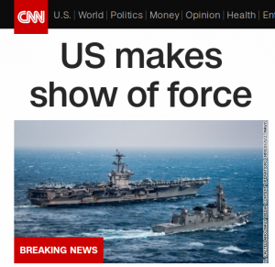
The US’ “subtle hint” to the DPRK and China
Now let’s look at what happened from the point of view of China and the DPRK. First, as I mentioned, I don’t think that Xi felt that the attack during his visit to the USA was a slap or an affront. From another civilized country, maybe. But not from the USA. The Chinese are absolutely under no illusion of the total lack of sophistication and even basic manners of US Presidents. That is not to say that they were not outraged and very concerned. It goes without saying that they also noticed the “coincidence” that The USN has canceled planned port calls in Australia for the USS Carl Vinson and is instead sending the aircraft carrier and attached group towards the Korean Peninsula. They also noticed that this move has been given maximal visibility in the US propaganda machine. One “show of force” in Syria is now followed by another “show of force” in East Asia.
Typical, isn’t it?
If anything, this move will only strengthen the informal but very strong and deep partnership between China and Russia. Just like the Russians, the Chinese will keep on smiling and make very nice statements about international peace and security, negotiations, etc. But everybody who matters in China will understand that the real message of out Washington DC is simple: “now it’s Assad – but you could be next”.
Which leaves the DPRK. I am no mind-reader and no psychologist, but I ask myself the following question: what is worse – if the Americans fail to really scare Kim Jong-un or if they successfully do? I don’t have the answer, but considering the past behavior of the DPRK leaders I would strongly suggest that both scaring them and failing to scare them are very dangerous options. The notion of “scare” should not be included in any policies dealing with the DPRK. But instead of that, the dummies in DC are now leaking a story (whether true or not) that the US intelligence agencies have finalized plans to, I kid you not, “eliminate Kim Jong-un“. And just to make sure that the message gets through, the latest US harpy at the UNSC threatens the DPRK with war.
Have they all really gone totally insane in Washington DC?
Do I really need to explain here why war with the DPRK is a terrible idea, even if it had no nuclear weapons?
Conclusion: what happens next?
Simply reply: I don’t know. But let me explain why I don’t know. In all my years of training and work as a military analyst I have always had to assume that everybody involved was what we called a “rational actor”. The Soviets sure where. As where the Americans. Then, starting with Obama more and more often I had to question that assumption as the US engaged in what appeared to be crazy and self-defeating actions. You tell me – how does deterrence work on a person with no self-preservation instinct (whether as a result of infinite imperial hubris garden variety petty arrogance, crass ignorance or plain stupidity)? I don’t know. To answer that question a what is needed is not a military analyst, but some kind of shrink specializing in delusional and suicidal types.
Some readers might think that this is hyperbole. I assure you that this is not. I am dead serious. Not only do I find the Trump administration “not agreement capable”, I find it completely detached from reality. Delusional in other words. You think Kim Jong-un with nukes is bad? What about Obama or Trump with nukes? Ain’t they much, much scarier?
So what can the world do?
First, the easy answer: the Europeans. They can do nothing. They are irrelevant. They don’t even exist. At least not in the political sense.
Some countries, however, are showing an absolutely amazing level of courage. Look at what the Bolivian representative at the UNSC dared to do:
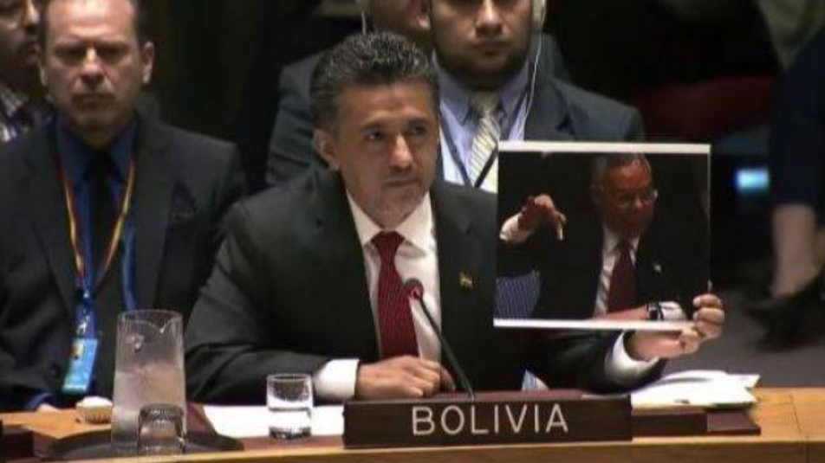
Bolivia: a profile in courage
And what a shame for Europe: a small and poor country like Bolivia showed more dignity that the entire European continent. No wonder the Russians have no respect for the EU whatsoever.
What Bolivia did is both beautiful and noble. But the two countries which really need to step up to the plate are Russia and China. So far, it has been Russia who did all the hard work and, paradoxically, it has been Russia which has been the object of the dumbest and most ungrateful lack of gratitude (especially from armchair warriors). This needs to change. China has many more means to pressure the USA back into some semi-sane mental state than Russia. All Russia has are superb military capabilities. China, in contrast, has the ability to hurt the USA where it really matters: money. Russia is in a pickle: she cannot abandon Syria to the Takfiri crazies, but neither can she go to nuclear war with the USA over Syria. The problem is not Assad. The problem is that he is the only person capable, at least at this point in time, to protect Syria against Daesh. If Assad is removed, Syria falls and Iran is next. Russia absolutely cannot afford to have Iran destroyed by the Anglo-Zionists because after Iran, she will next. Everybody in Russia understands that. But, as I said, the problem with military responses is that they can lead to military escalations which then lead to wars which might turn nuclear very fast. So here is my central thesis:
You don’t want Russia to stop the USA by purely military means as this places the survival of of mankind at risk.
I realize that for some this might be counter-intuitive, but remember that deterrences only works with rational actors. Russia has already done a lot, more than everybody else besides Iran. And if Russia is not the world’s policeman, neither is she the world savior. The rest of mankind also needs to stop being a silent bystander and actually do something!
Russia and China can stop the US, but they need to do that together. And for that, Xi needs to stop acting like a detached smiling little Buddha statue and speak up loud and clear. That is especially true since the Americans show even less fear of China than of Russia.
[Sidebar: the Chinese military is still far behind the kind of capabilities Russia has, but the Chinese are catching up really, really fast. Just 30 years ago the Chinese military used to be outdated and primitive. This is not the case today. The Chinese have done some tremendous progress in a record time and their military is now a totally different beast than what it used to be. I have no doubt at all that the US cannot win a war with China either, especially not anywhere near the Chinese mainland. Furthermore, I expect the Chinese to go full steam ahead with a very energetic military modernization program which will allow them to close the gap with the USA and Russia in record time. So any notions of the USA using force against China, be it over Taiwan or the DPRK, is an absolutely terrible idea, sheer madness. However, and maybe because the Americans believe their own propaganda, it seems to me like the folks in DC think that we are in the 1950s or 1960 and that they can terrify the “Chinese communist peasants” with their carrier battle groups. What the fail to realize is that with every nautical mile the US carriers make towards China, the bigger and easier target they make for a military which has specialized in US carrier destruction operatons. The Americans ought to ask themselves a simple question: what will they do if the Chinese either sink or severely damage one (or several) US Navy carriers? Go to nuclear war with a nuclear China well capable of turning many US cities into nuclear wastelands? Really? You would trade New York or San Francisco for the Carl Vinson Strike Group? Think again.]
So far China has been supporting Russia, but only from behind Russia. This is very nice and very prudent, but Russia is rapidly running out of resources. If there was a sane man in the White House, one who would never ever do something which might result in war with Russia, that would not be a problem. Alas, just like Obama before him, Trump seems to think that he can win a game of nuclear chicken against Russia. But he can’t. Let me be clear he: if pushed into a corner the Russian will fight, even if that means nuclear war. I have said this over and over again, there are two differences between the Americans and the Russians
- The Russians are afraid of war. The Americans are not.
- The Russians are ready for war. The Americans are not.
The problem is that every sign of Russian caution and every Russian attempt to de-escalate the situation (be it in the Ukraine, with Turkey or in Syria) has always been interpreted by the West as a sign of weakness. This is what happens when there is a clash between a culture which places a premium on boasting and threatening and one which believes in diplomacy and negotiations.
[Sidebar. The profound cultural differences between the USA and Russia are perfectly illustrated with the polar difference the two countries have towards their most advanced weapons systems. As soon as the Americans declassify one of their weapon systems they engage into a huge marketing campaign to describe it as the “bestest of the bestest” “in the world” (always, “in the world” as if somebody bothered to research this or even compare). They explain at length how awesome their technology is and how invincible it makes them. The perfect illustration is all the (now, in retrospect, rather ridiculous) propaganda about stealth and stealth aircraft. The Russians do the exact opposite. First, they try to classify it all. But then, when eventually they declassify a weapons system, they strenuously under-report its real capabilities even when it is quite clear that the entire planet already knows the truth! There have been any instances when Soviet disarmament negotiators knew less about the real Soviet capabilities than their American counterparts! Finally, when the Russian export their weapons systems, they always strongly degrade the export model, at least that was the model until the Russians sold the SU-30MKI to India which included thrust vectoring while the Russian SU-30 only acquired later with the SU-30SM model, so this might be changing. Ask yourself: did you ever hear about the Russian Kalibr cruise missile before their first use in Syria? Or did you know that Russia has had nuclear underwater missiles since the late 1970s capable of “flying under water” as speeds exceeding 230 miles per hour?]
Russia is in a very difficult situation and a very bad one. And she is very much alone. European are cowards. Latin Americans have more courage, but no means to put pressure on the USA. India hopes to play both sides. Japan and the ROK are US colonies. Australia and New Zealand belong to the ECHELON/FIVE EYES gang. Russia has plenty of friends in Africa, but they more or less all live under the American/French boot. Iran has already sacrificed more than any other country and taken the biggest risks. It would be totally unfair to ask the Iranians to do more. The only actor out there who can do something in China. If there is any hopes to avoid four more years of “Obama-style nightmare” it is for China to step in and tell the US to cool it.
In the meantime Russia will walk a very fine like between various bad options. Her best hope, and the best hope of the rest of mankind, is that the US elites become so involved into fighting each other that this will leave very little time to do any foreign policy. Alas, it appears that Trump has “figured out” that one way to be smart (or so he thinks) in internal politics is to do something dumb in external politics (like attack Syria). That won’t work.
Maybe an impeachment of Trump could prove to be a blessing in disguise. If Mike Pence becomes President, he and his Neocons will have total power again and they won’t have to prove that they are tough by doing stupid and dangerous things? Could President Pence be better than President Trump? I am afraid that it might. Especially if that triggers a deep internal crisis inside the USA.
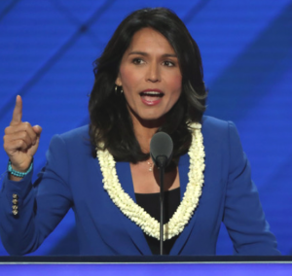
Is she the last hope for the USA?
The next four years will be terrible, I am sorry to say. Our next hope – however thin – for somebody sane in the White House might be for 2020. Maybe Tulsi Gabbard will run on a campaign promise of peace and truly draining the swamp? Maybe “America first” will mean something if Gabbard says it? Right now she seems to be pretty much the only one refusing the accept the “Assad did it” nonsense. So maybe she can provide the mix of peace and progressive social policies so many Americans really want? Maybe she could become the first woman President for all the right, rather then wrong, reasons. I don’t know. 2020 is still very, very far away, let’s just hope we all make it to that date before some imbecile in DC decides that war with Russia is a good idea.
What is certain is that the Democrat vs. Republican and Conservative vs Liberal dichotomy only serves to perpetuate a system which manages to betray the values of BOTH the Left and the Right. This is paradoxical because it is pretty darn clear that most Americans want their country to be at peace, to stop being constantly at war, and with civilized social and labor standards. Sure, the hardcore libertarians still believe that laisser-faire is a great solution, even if that hands all the power to corporations and even if that leaves the individual citizen defenseless against the oligarchy. But bet you that even hardcore libertarians would prefer “statism” (as they would say) with peace than “statism” with war. Likewise, many hardcore progressives want to severely limit the freedoms of many Americans (small business entrepreneurs, gun owners), but even they would prefer peace without rules and regulations than war without rules and regulations. So I think that the possibly unifying platform could be expressed in the notion of “peace and civil rights”. That is something which the vast majority of Americans can agree upon. Even the Black Lives Matter folks should agree to that kind of “peace and civil rights platform”. That, I think, ought to be the priority of the Federal government – dismantle the war machine and dismantle the state repression machine: a full pull-out of US forces deployed worldwide combined with a full restoration of civil and human rights as they were before the 9/11 false flag. And let the States deal with all the other issues.
Alas, I am afraid that the plutocracy in power will never allow that. The way the crushed Trump in one month tells me that they will do that to anybody who is not one of their own. So while hope is always a good thing, and while I like dreaming of a better future, I am not holding my breath. I find a sudden and brutal collapse of the Anglo-Zionist Empire followed by a break-up of the USA (as described here) far more likely.
We better prepare ourselves for some very tough times ahead.
Our only consolation is that all the dramatic events taking place right now in the USA are signs of weakness. The US elites are turning on each other and while the Neocons have broken Trump, this will not stop the fratricidal war inside the US plutocracy. Look at the big picture, at how the empire is cracking at every seam and remember that all this is taking place because we are winning.
Imperialism will die, discredited and hated by all those who will have to live through the upcoming collapse of the US-based AngloZionist Empire. Hopefully this time it will be the last empire in history and mankind will have learned its lesson (it would be about time!).
The Saker

